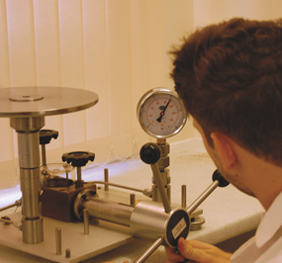
What is calibration?

- Calibration is the process of checking, by comparison with a standard, the accuracy of a measuring instrument and provides corrections which can be applied to the readings obtained in use.

- Deadweight testers are used to calibrate pressure measuring instruments; they use calibrated weights to apply known pressures to a device under test.

Why should I calibrate my pressure gauge?

- By comparing an instrument of a known value against a second instrument (unit under test), the difference can be calculated, and suitable corrections determined.

- A calibration provides the user with confidence that the instrument they are using works correctly.

- Without periodic calibration, an instrument may drift out of the manufacturer’s specification without anyone realising and lead to incorrect test results

How often should I calibrate my pressure gauge?

- We recommend getting your instrument calibrated at least every 12 months, however the calibration frequency for a specific gauge is up to the user. It should be based on:

  - The environment in which the instrument is used
  - The frequency of use
  - Any evidence of changes or trends in calibration data

- The user must decide what is the consequence of an incorrect reading and schedule the calibration frequency accordingly.

What calibration options do I have?

- In Brannan’s calibration laboratory we are able to calibrate instruments up to 700 bar.

- Our calibrations are carried out at 5 points, spread across the full range of the gauge.

- We offer both UKAS & Traceable Calibration Certificates.

To find out more about calibration for your pressure gauge, please contact sales@brannan.co.uk

